**Tebeletso Ramokhele 90101869**

**Tsepang Lebeko 901019676**

**Nthuseng Mokhomo 901019352**

**Lebohang Thaanyane 901019589**

**Design Choices Presentation**

1. User Experience (UX)

* **Simple Navigation Bar:**  
  The top navigation menu (“Home, About, Clubs, Events, Contact”) ensures users can easily find key sections. It is consistent across pages to improve orientation and flow.
* **Clear Hierarchy:**  
  Headings like “Who We Are”, “Our Mission”, and “Meet Our Team” structure the content clearly, making it easy for users to scan and understand.
* **Visual Consistency:**  
  Each page uses similar layouts (banner, content blocks, footer), giving a cohesive experience and improving learnability.
* **Use of Imagery:**  
  Team photos and event images create connection and engagement, making the site feel more human and relatable.
* **Footer for Attribution:**  
  The footer includes &copy details and credits, helping users trust the source and understand ownership.

**2. Color Choices**

* **Primary Color: Deep Blue (#003366 or similar)**  
  Used for the header and footer, blue symbolizes trust, reliability, and professionalism—fitting for a university environment.
* **Secondary Color: White Background (#FFFFFF)**  
  Provides excellent contrast, improving readability and giving the site a clean, modern look.
* **Accent Colors:**  
  Light grey (#F5F5F5) backgrounds separate sections subtly, improving content grouping without overwhelming users.
* **Text Colors:**  
  Black and dark grey text ensure maximum legibility on light backgrounds.

**3. Accessibility**

* **Color Contrast:**  
  The dark blue against white ensures strong contrast, meeting WCAG accessibility guidelines for text readability.
* **Readable Fonts:**  
  Clear sans-serif fonts (e.g., Arial, Helvetica) enhance legibility for users with reading or vision difficulties.
* **Alt Text & Labels:**  
  Each team image or event photo can include descriptive *alt text* so screen readers can describe them to visually impaired users.
* **Consistent Structure:**  
  Logical heading levels (H1, H2, H3) and link labels (“Home,” “About,” etc.) make the site easily navigable by assistive technologies.
* **Keyboard Accessibility:**  
  The simple menu and link structure support navigation using only the keyboard.

**4. Overall Aesthetic**

The design balances professionalism with friendliness—blue tones build trust while photos and rounded layouts create warmth and community appeal. The visual hierarchy and whitespace make the design uncluttered and student-friendly

**Limkokwing Clubs Website Documentation**

**1. Project Overview**

The University Clubs Website is designed to showcase the various student clubs, their missions, upcoming events, and team members. It aims to encourage student participation and strengthen the sense of community on campus.

**2. Team Roles**

| **Name** | **Role** | **Responsibilities** |
| --- | --- | --- |
| **Lebohang Thaanyane** | Club Coordinator | Oversaw project structure, coordinated content, and ensured timely updates. |
| **Tebeleletso Ramokhele** | Event Organizer | Collected and organized event data, created event content, and reviewed design layouts. |
| **Ts’epang Lebeko** | Public Relations Officer | Managed content tone, wrote text for “About” and “Mission” sections, and verified club information. |
| **Nthuseng Mokhomo** | Creative Designer | Created the design layout, color palette, and page structure using Figma and HTML/CSS. |

**3. Wireframe Description**

**Page 1 – Home:**

* Header: College Clubs title and navigation menu.
* Sections: Welcome message, highlights of clubs, and quick links.

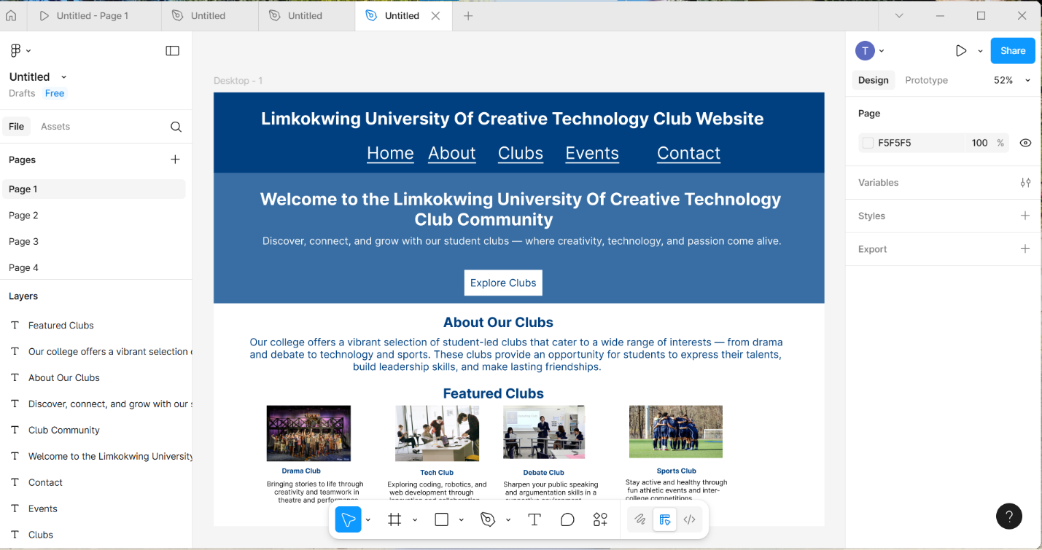

**Page 2 – About:**

* “Who We Are,” “Mission,” and “Vision” sections to explain club goals.
* “Meet Our Team” section with circular profile images and names.

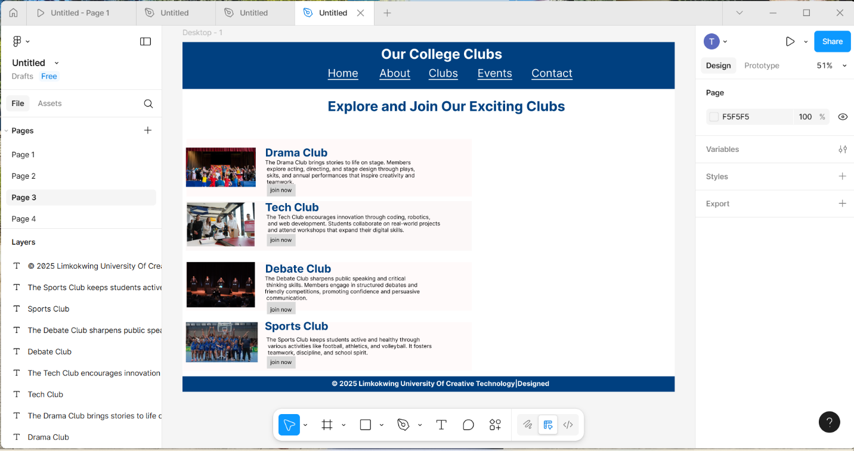

**Page 3 – Clubs:**

* Lists various clubs (Drama, Tech, Debate, Sports) with short descriptions.



**Page 4 – Events:**

* Upcoming event cards with event images, titles, dates, and locations.

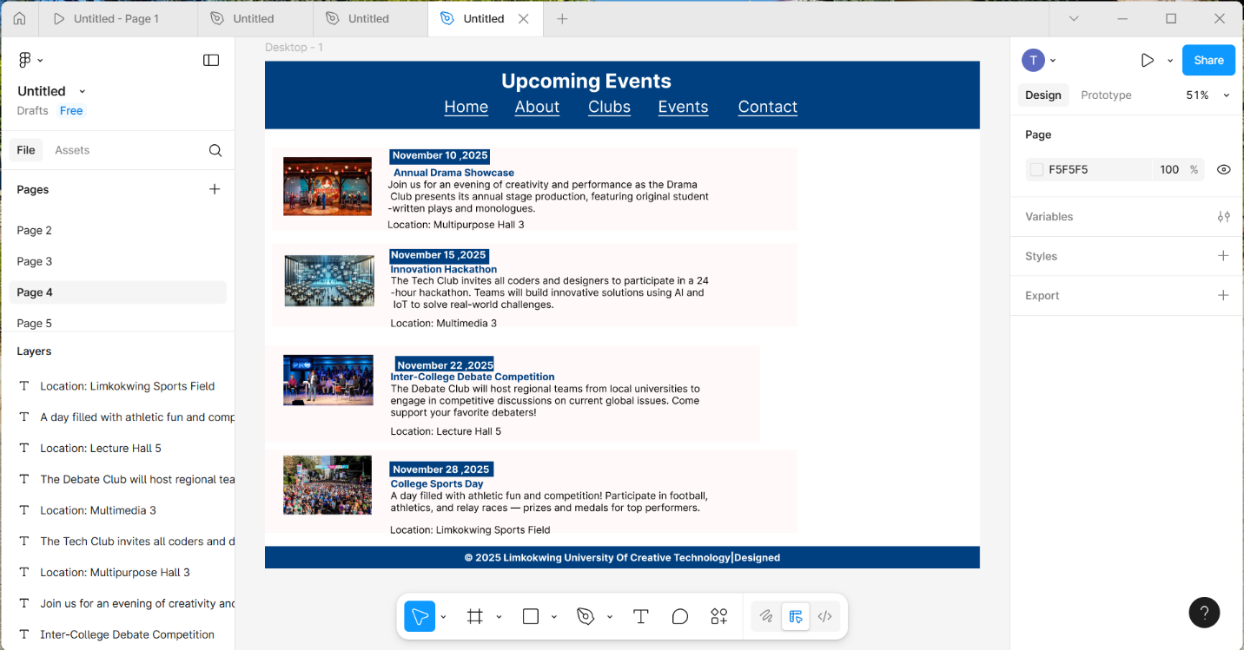

**Page 5 – Contact:**

* Simple contact form (Name, Email, Message).

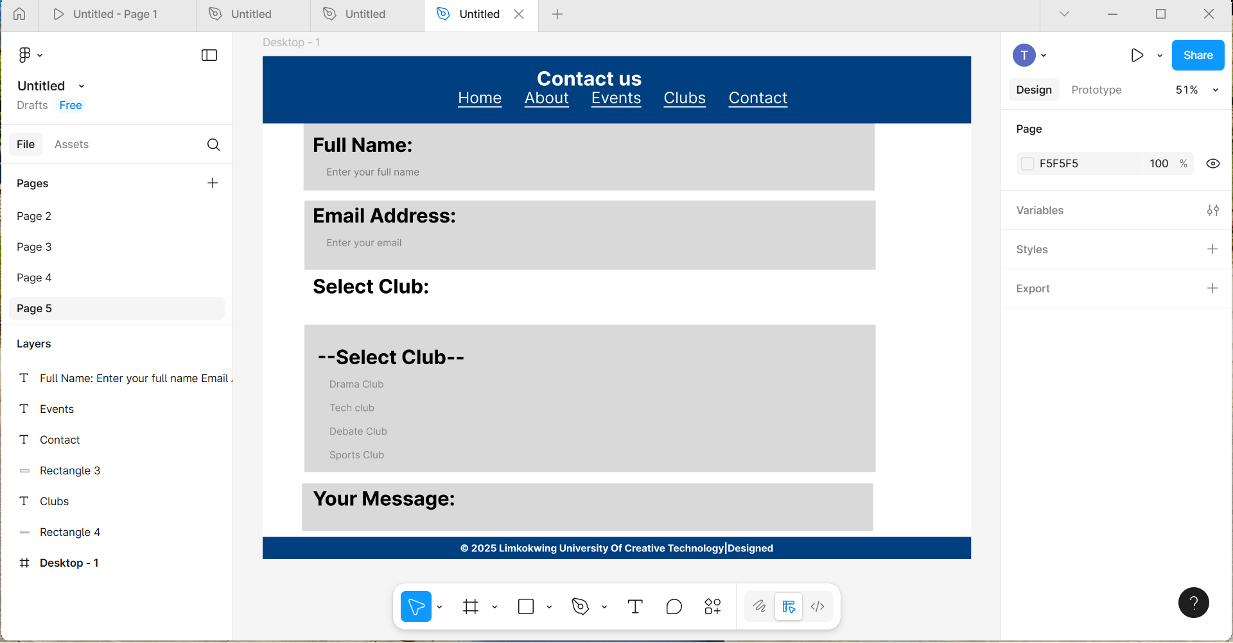

**Design Layout Summary:**  
Top blue navigation bar → white content sections → blue footer with copyright text.  
Clean, minimal, and visually structured for easy scanning.

**4. Code Snippets**

**Index.html (with internal CSS & JS example)**

<!DOCTYPE html>

<html lang="en">

<head>

<meta charset="UTF-8">

<meta name="viewport" content="width=device-width, initial-scale=1.0">

<title>About Our College Clubs</title>

<style>

body {

font-family: Arial, sans-serif;

background-color: #f5f5f5;

margin: 0;

padding: 0;

}

header {

background-color: #003366;

color: white;

text-align: center;

padding: 20px 0;

}

nav a {

color: white;

margin: 0 15px;

text-decoration: none;

font-weight: bold;

}

section {

background-color: white;

margin: 20px auto;

padding: 20px;

max-width: 900px;

border-radius: 10px;

}

h2 {

color: #003366;

}

.team {

display: flex;

justify-content: space-around;

flex-wrap: wrap;

}

.member {

text-align: center;

}

.member img {

border-radius: 50%;

width: 100px;

height: 100px;

}

footer {

background-color: #003366;

color: white;

text-align: center;

padding: 10px;

}

</style>

<script>

function showWelcome() {

alert("Welcome to Our College Clubs Website!");

}

</script>

</head>

<body onload="showWelcome()">

<header>

<h1>About Our College Clubs</h1>

<nav>

<a href="#">Home</a>

<a href="#">About</a>

<a href="#">Clubs</a>

<a href="#">Events</a>

<a href="#">Contact</a>

</nav>

</header>

<section>

<h2>Who We Are</h2>

<p>Our College Club community is a dynamic hub for students to explore their interests and build leadership skills.</p>

</section>

<section>

<h2>Meet Our Team</h2>

<div class="team">

<div class="member">

<img src="team1.jpg" alt="Lebohang">

<p><b>Lebohang Thaanyane</b><br>Club Coordinator</p>

</div>

<div class="member">

<img src="team2.jpg" alt="Tebeleletso">

<p><b>Tebeleletso Ramokhele</b><br>Event Organizer</p>

</div>

<div class="member">

<img src="team3.jpg" alt="Ts'epang">

<p><b>Ts'epang Lebeko</b><br>Public Relations Officer</p>

</div>

<div class="member">

<img src="team4.jpg" alt="Nthuseng">

<p><b>Nthuseng Mokhomo</b><br>Creative Designer</p>

</div>

</div>

</section>

<footer>

&copy; 2025 Limkokwing University Of Creative Technology | Designed by Team Clubs

</footer>

</body>

</html>

**5. Deployment Steps**

**Step 1:**  
Create a project folder, e.g. college-clubs-site/

**Step 2:**  
Inside the folder, add your HTML files:  
index.html, about.html, clubs.html, events.html, contact.html

**Step 3:**  
Add your image folder:  
/images/ → contains photos for team members and events.

**Step 4:**  
If you use external CSS/JS, add:  
style.css and script.js in separate folders (/css/ and /js/).

**Step 5:**  
Test locally by double-clicking index.html in your browser.

**Step 6:**  
Deploy online:

* Upload to **GitHub Pages**, **Netlify**, or **Vercel**  
  Top of Form

Bottom of Form